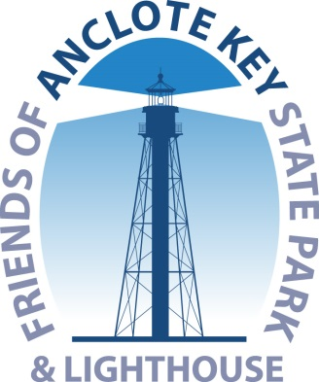
Yearly Membership Form
Friends of Anclote Key State Park & Lighthouse -
Supporting and Promoting our Island Park
PO Box 2622, Tarpon Springs FL 34688
Phone: 727-772-9800
www.AncloteCSO.org Join online
Like us on Facebook! ~ https://www.facebook.com/AncloteKeyLighthouse/

Corporate membership - $250.00 (USD) Includes Logo on the Website
Family Membership - $35.00 (USD) Bundle (up to 6 members total)
Individual Membership - $25.00 (USD)
Student Membership - $10.00 (USD) Full Time Students or Students currently enrolled in a Degree Program

Primary Member
Company if Corporate Member________________________________________
First Name ________________________________________________________
Last Name ________________________________________________________
Email ____________________________________________________________
Home Phone _______________________Mobile Phone____________________
Address _________________________________ City _____________________
State __________________________ Zip________________ Seasonal?

Family Members
Name_____________________________Email:__________________________
Name_____________________________Email:__________________________
Name_____________________________ Email:__________________________
Name_____________________________ Email:__________________________
Name_____________________________ Email:_________________________

Check Payment: Make out to Friends of Anclote Key (check #________)

Credit Card Payment:
MC or Visa card Number ________________________ Code ______________
Name on Card _____________________ Expiration ______________________ Signature _________________________________Zip Code________________

